**Excel Functions**

**Example 1:** Monthly Budget of Common man by using a sum function.

**1.Sum ( )**

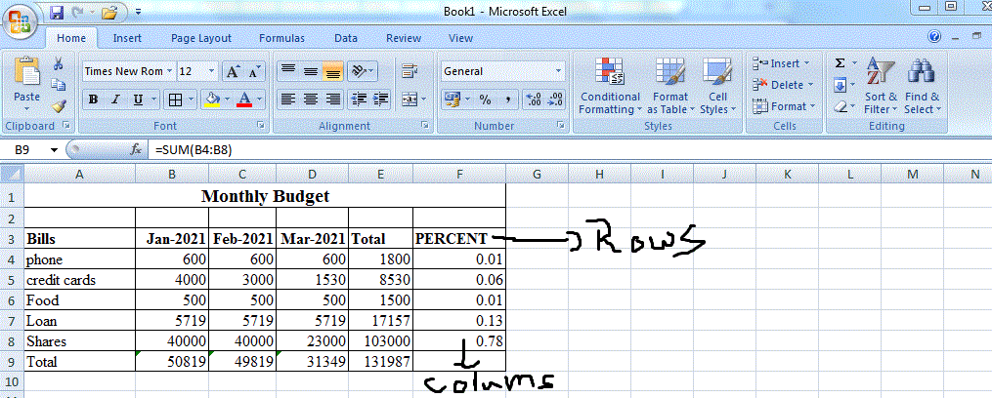

**2.Min ( ) and Max( )**

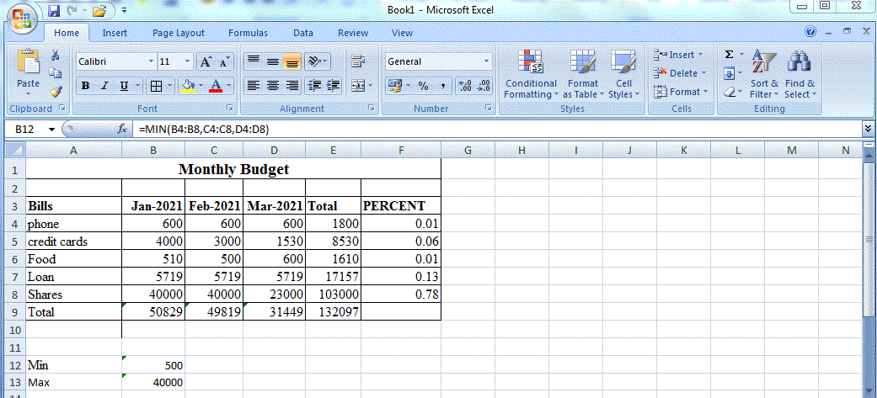

**3.Average ( )**

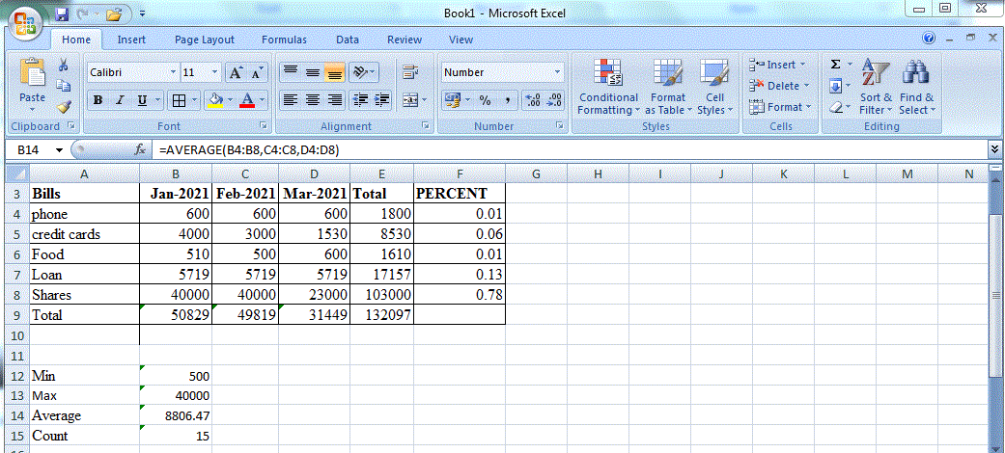

**4.Count**

